

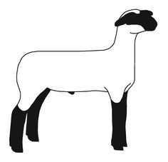
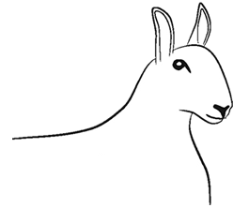
Friday, July 31
7:00am-9:00am EST Check in Registered Ewes
Check in Market Lambs & Commercial Ewes
8:00am-1:00pm EST Sheep Skillathon Open for all exhibitors
10:00am EST Registered Ewe Showmanship
Registered Ewe Show (Breed Champions selected during show)
Supreme Champion Ewe
County Group-of-Three Registered Ewes
Market Type Showmanship (will follow completion of Breeding Ewe Show)
Commercial Ewe Show
Champion Commercial Ewe Show
County Group-of-Three Commercial Ewes
Market Lamb Show
Champion Market Lamb Show
County Group-of-Three Market Lambs
Premier Exhibitor Awards and Skillathon Awards
EASTERN REGION 4-H SHEEP EXPO
July 30-31, 2026
Appalachian Fairgrounds
Gray, TN
Schedule:
Thursday, July 30
4:00pm-6:30pm EST Early Check in for exhibitors
7:00pm-8:00pm EST Ice Cream Social and Games

