Fall 2025
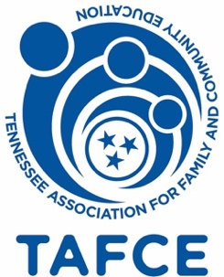 The Messenger
Newsletter of the Eastern Region Family and Community Education
Website: Eastern.Tennessee.edu, then Click on Family and Consumer Science
Facebook: Eastern Region FCE

A note from your Eastern President: Marti Agler

Beautiful fall, cool nights but sunny days; what’s not to like?!?!

Fall is a busy time in TAFCE Eastern Region; we have a service project as part of FCE Day at the TVA Fair, annual Cultural Arts and Fashion Review competition, 2026 event planning, State Conference, and 2026 Planner compilation. Whew!

For those who helped with the service project for Random Acts of Flowers at TVA Fair, thank you. What a good feeling to provide a moment of pleasure to 82 people who have few of those moments available to them.

By the time you are reading this, the annual Cultural Arts and Fashion Review competitions will be over, we hope each of you took home some of those honors! There is such talent in the Eastern Region, I am always in awe of the talent you have.

At the Fall Conference, you were given the 2026 Proposed Budget and the Officer Nominations from the Nominating Committee. Please give these items your careful thought, ask questions, and make a solid decision, voting will be at the November member meeting in Murfreesboro. Your Board serves at your pleasure and it is our duty to perform to your expectations. You cast the votes, you make the decisions.

Your Board will meet next on October 6 in Monroe County to plan the Regional events and activities for 2026. If you have some thoughts on plans we should consider, please advise any member of the board. Our goal is to provide regional events that you cannot bear to miss! Exciting, fun, full of information and ideas to make our communities thrive. We will also be moving forward with our marketing plan to promote FCE throughout the Eastern Region in a complete and uniform manner to bring our wonderful organization to more of our friends and neighbors. Again, your ideas are critical to the success of our organization!

As most of you are aware, your Board made the extremely difficult decision to step aside as chair of the 2026 TAFCE State Conference. Due to concerns as a result of a TAFCE Board member procedural error, we could not see a courteous, cooperative path forward that would allow us to curate the event successfully. The TAFCE Board was so advised.

Thank you for your help and support, you are the best!

Eastern Region Marketing

Do you have a background and experience in Marketing, Advertising, or Public Relations? Boy, howdy, does the Eastern Region need your skills for our project of creating common identifiers and recruiting materials. We began the process with the brainstorming at the Spring Event where we collected LOTS of words and phrases which we now have to distill. If you can offer some knowledgeable help with this, advise our Region President so she can pull you on board this temporary committee.

A Word from Eastern Region Treasurer: Pat Malbrough

Happy Fall Y’all!!

These cooler temps only mean 1 thing --- it’s time to send in your 2026 dues!! I hope all County Presidents and Treasurers received my email with the 2026 forms for Region/State and for National Dues. If you’re reading this, the deadline has probably passed. No problem. I will take dues anytime!!

As our President has been stressing this year, our main source of income is membership dues. Our goal in 2026 is to get our membership numbers back to where they were pre-Covid!!

Please ramp up your recruiting efforts!! Talk to your neighbors or the ladies in your Silver Sneakers class. Set up a table at any of your local events and talk to people about FCE. Pass out flyers. Have a tea party and invite your local community to introduce them to the benefits of joining FCE (plus the fun we have!). Get creative.

If anyone needs any assistance you can contact me at any time.

A Summary from Action Chair Activities: Barbara Mills

As we approach our Eastern Region Fall Festival, my term as Action Chair will come to a close.
In November 2023, at the Leadership Conference in Sevierville, TN, I was "voluntold" I should serve as ACTION Chair. I did not have a clue what my duties would be. All I knew was that I would find a charity for our spring meeting. However, I didn't know about the other responsibilities and stipulations.

I received a call from Marti Agler in January 2024, she gave me the information I needed in order to perform my duties as Action Chair. Marti is a great leader who appears to believe in building the members up, not attacking and tearing down. She treats all members of the board with respect and dignity as well as all members of the Eastern Region. With the training and support she gave me during my term, it has been my pleasure to serve as ACTION CHAIR.

In the past (2) two years, we have made contributions to (5) five charities in our Region.
Those charities are:
- Full Circle Medical Center for Women in Athens, TN
- Glenmore Historical Mansion in Jefferson City, TN
- Campbell County Special Olympics; in LaFollette, TN
- Teachers’ Supply Closet Roane County United Way in Kingston, TN
- The Avalon Center for Domestic Violence and Sexual Assault in Fentress County, Jamestown, TN

I look forward to seeing what we will do for the First Tennessee Agency on Aging and Disability in Sullivan County at our Fall Conference in Blountsville, TN.

As my term comes to a close, I want to say it has been my PLEASURE to serve in this position. I have learned a great deal and am thankful for the experience. To all the members of the Eastern Region, a great big THANK YOU for your generosity and support. Every member has that Tennessee volunteer Spirit.
Thank you for this great opportunity!

A Report from Cumberland County: Lake Tansi Club
Each year Lake Tansi FCE Club provides scholarships for children to attend 4-H camp. Fundraising for this event was held Saturday, September 13. Thanks to those who made donations for the silent auction. The club appreciates those who bought tickets for the luncheon and bid on auction items.
Here we are in our pretty purple, lunch and fun!
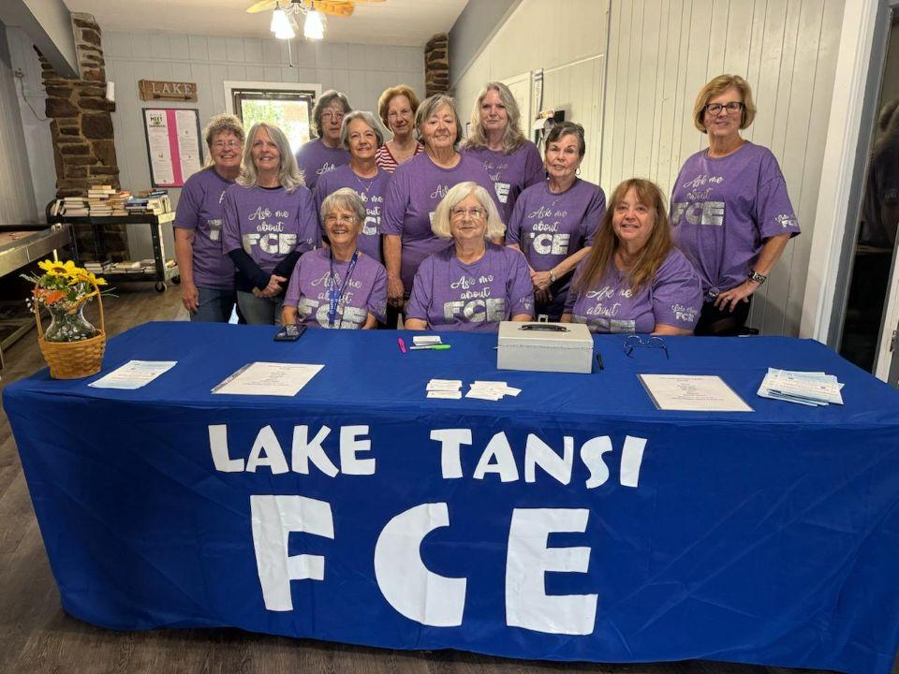

Book Review from Your Secretary, Gloria Fisher

I am on a journey to change habits so that I can get the most out of my remaining life. That desire has led me to research the path I need to take for myself.
I was told to exercise and change how I eat. No small task! I struggled with how.

Two weeks ago, a book title caught my attention. I felt compelled to read “Dark Calories: How Vegetable Oil Destroys Our Health and How We Can Get It Back” by Catherine Shanahan MD trained in biochemistry at Cornell.

“Dark Calories” tells vegetables oils (seed oils including canola, cotton seed, soy, safflower, grapeseed, rice bran, and sunflower) are not good for us and why.

Shanahan’s book delivers clarifying information backed by sound research and reasoning why these highly processed oils have a negative impact. Their processing leaves them high in polyunsaturated fatty acids, resulting in the oils being unstable.

She professes that such oils may contribute to chronic conditions like obesity, inflammation and metabolic disorders. Furthermore, she says they can cause uncontrollable hunger, inflammatory fat buildup fat buildup, disruptive brain energy, gut inflammation and intercellular oxidation.

Shanahan promotes healthy unprocessed tree oils (olive, avocado, and coconut) as they have a natural balance of omega 3 and omega 6.

​​Some Words from Monroe County: Tammye Miller, President
Monroe County
Community Circle Club
Tom McCosh, Monroe County airport manager, gave our group a wonderful tour of the airport, including the mechanics shop, the runway, and we got to check out a small plane up close and personal. Tom also made a nice lunch for our group. We all learned a lot about the airport and got our Monroe County passport stamped.
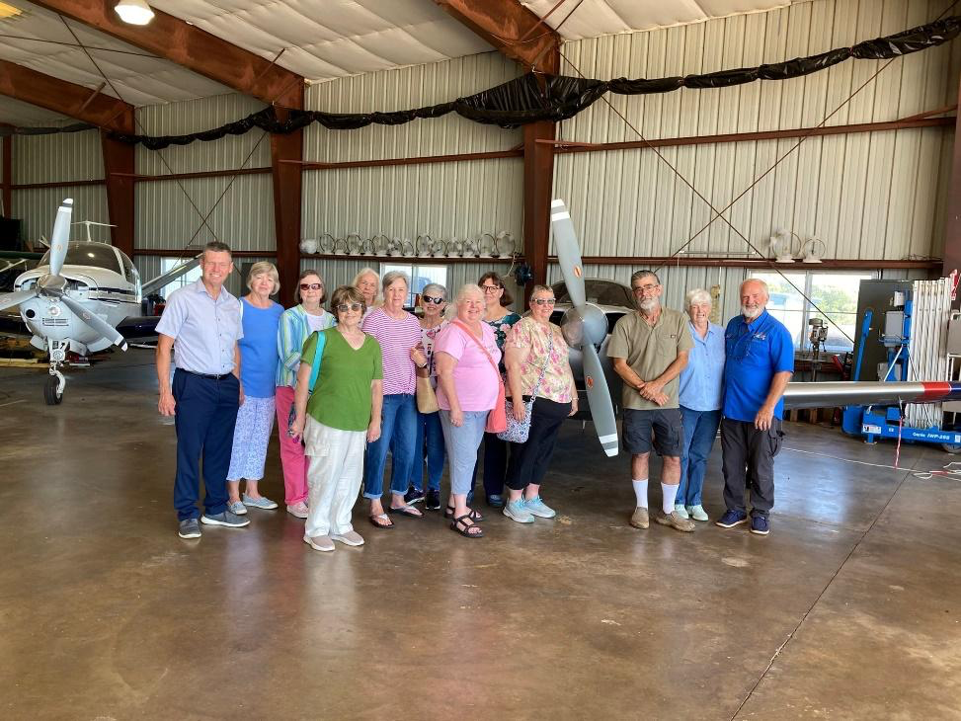
These ladies will also be hosting a Garage/Bake Sale on September 13th at Madisonville Flea market to raise money for Monroe County Cancer Transportation Fund.

Callie Cobb Club
These club members have been working hard with a lot on Community Activities. We collected underwear, shirts, pants and socks for the Elementary School for their Clothes closet. We also collected hygiene items, socks, hats, shirts, underwear for our Veterans. We have been having fund raisers for the Monroe K-9 Officer for his bullet proof vest. We will have a Parade of Prizes and Ladies Luncheon to raise funds for the K-9 Dog.

Monroe County Cultural Arts and Dress Revue
We had a great turn out for our County Cultural Arts and Dress Revue. Lots of Categories were entered in both Cultural Arts and Dress Revue. Blaina Best with Monroe County Tourism spoke with our group that day. We also hosted the 4-H Bread Baking Contest. Lunch was provided by the two clubs Callie Cobb and Community Circle. We had great food along with a great time together. Looking forward to seeing all the winner participate in the Eastern Region Cultural Arts and Dress Revue.

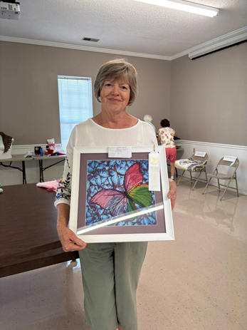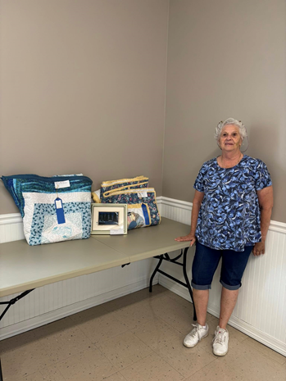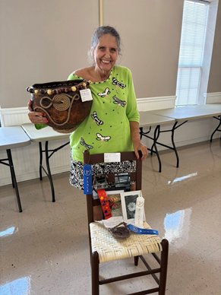
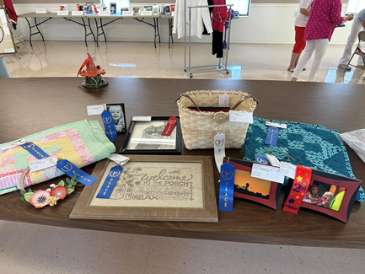
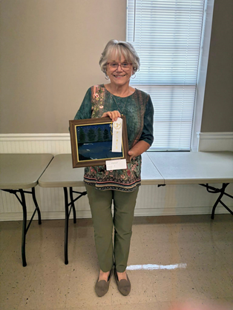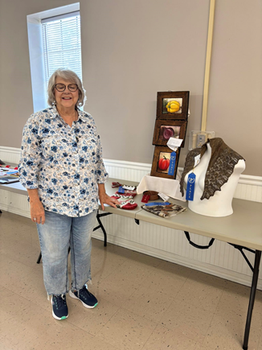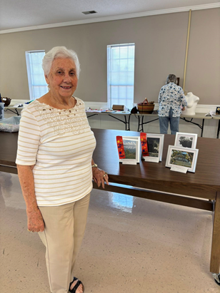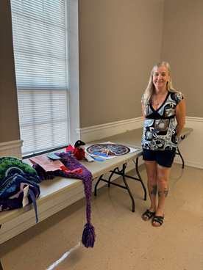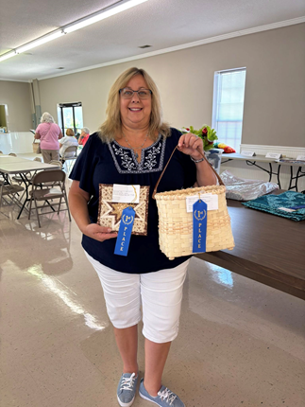
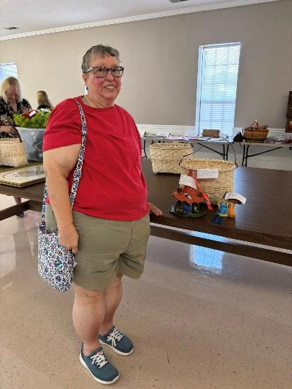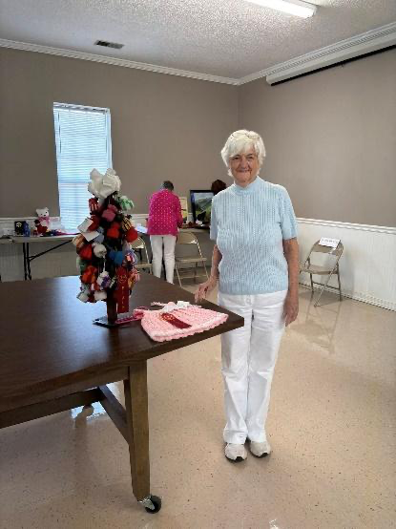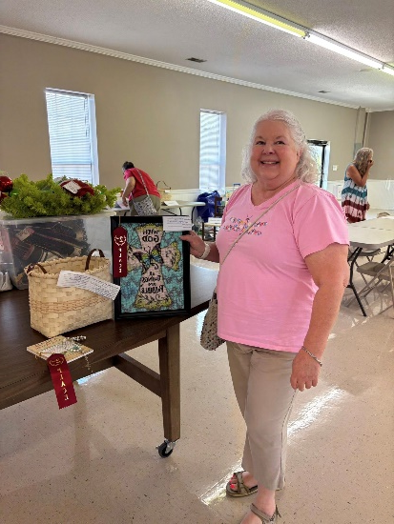
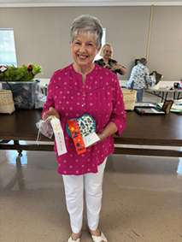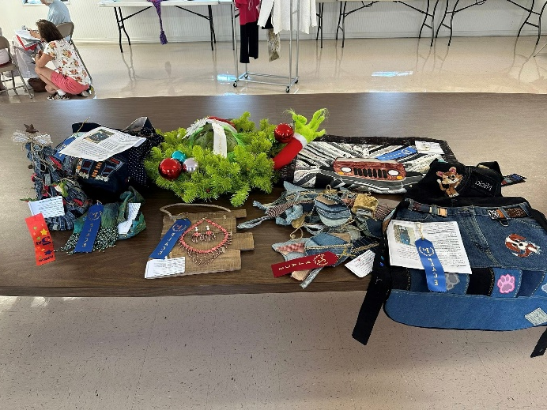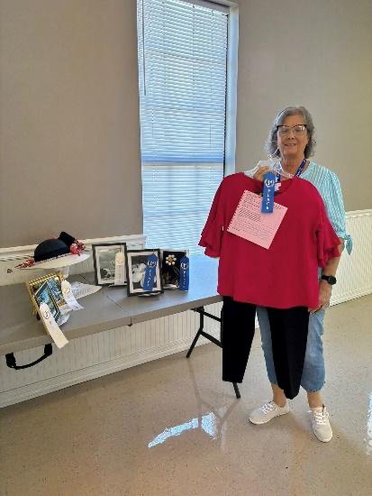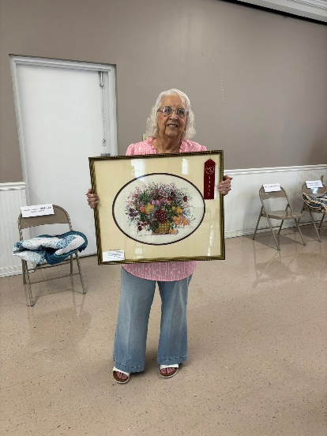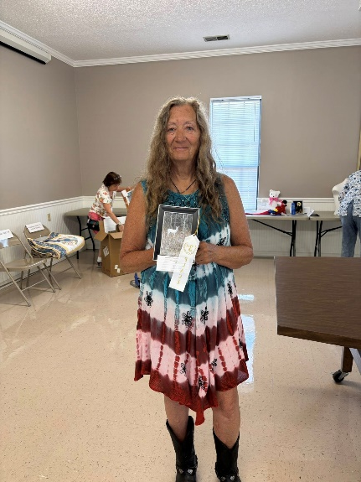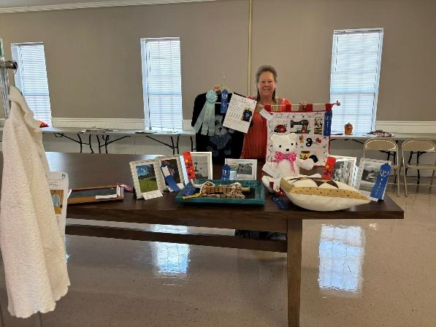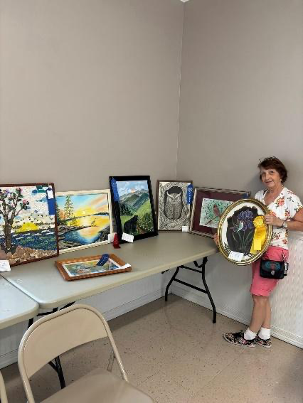

News from Sevier County: Marti Agler, President

Sevier County Uses Regional Grant Funds

Sevier County FCE received a Regional Grant in 2024 to promote homemaker skills at the Sevier County Fair. For the 2025 Fair, the exhibit class chosen was “Sewing”. The first winning entry was a beautifully finished tote bag entered by a non-member who has since indicated an interest in becoming a FCE member! This is success on two levels.

The workmanship on the bag was excellent and was certainly a worthy recipient of the $50.00 cash award! This item is also eligible to be taken to the 2026 Tennessee State Fair for competition. Congratulations to the 2025 recipient of the Sevier County FCE Best in Class Award!

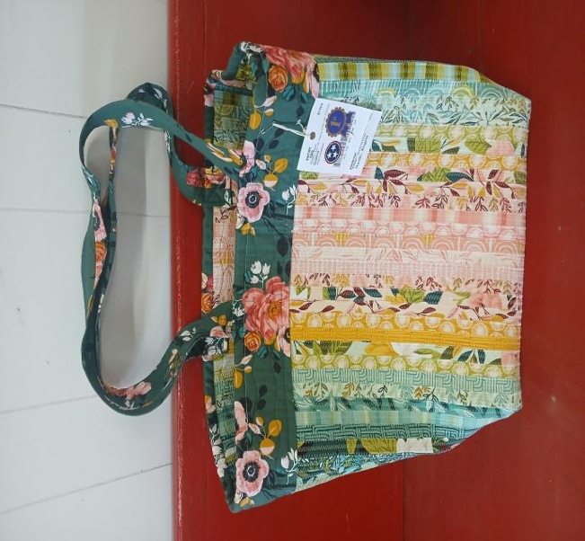

A word from Cultural Arts: Tammy Haliburton

Happy Fall Ya’ll,

“Crafting is the art of turning ordinary objects into extraordinary things”

I would like to thank the Sullivan County members for a great Fall Conference. As always it is exciting to see friends we have not seen in a while. For some of us it was fun to travel across the region.

I love seeing all the memories you have made in Cultural Arts. There were 11 counties reporting entries. The total number of entries were 283. Thank you!

This will be my last year on the Eastern Board. I would encourage you to think about taking a position of the board.

I hope to see all of you at State Conference in November.

Results from Dress Review Chair: Tammye Miller
Eastern Region Fall Event
It’s Harvest Time in FCE
Dress Revue Report
September 15th Eastern Region held their fall event in Sullivan County. First and Second place winners from each county entered their items in the Dress Revue. A special Thanks to our Two Judges-Barbara Stitt and Mary Leonard. They really looked over every garment with a fine tooth comb.
Winners were:
1. Donzettia Bean- Anderson County- Casual and Active Wear- 2nd place
2. Donzettia Bean- Anderson County- Children’s Casual wear- 2nd place
3. Tammye Miller- Monroe County- Recycled Garment-1st place
4. Nicola Briddon- Monroe County- Wardrobe Accessory-1st place
5. Deborah Paxton-Monroe County- Wardrobe Accessory-2nd place
6. Tammye Miller-Monroe County- Embellished T-shirt-1st place
7. Leslye Beria-Monroe County- Embellished t-shirt-2nd place
8. Doris FoxFeathers-Monroe County-Embellished Accessories-1st place
9. Dianna Forrest-McMinn County- Embellished Accessories-2nd place
10. Cynthia Mishtal-McMinn County-Embellished Aprons-1st place
11. Nicola Briddon-MonroeCounty-Constructed Apron-1st place
12. Sharon Clark-Greene County-Constructed Apron-2nd place
13. Judy Cohan-Anderson County-My Best Fashion Purchase Casual-1st place
14.Patricia Malbrough-Monroe County-My best fashion Purchase Casual-2nd place
15. Janice Reeves-Hawkins County-My best fashion Purchase Better Dress-1st place
16. Leslye Beria-McMinn County-My best fashion purchase Better Dress-2nd place
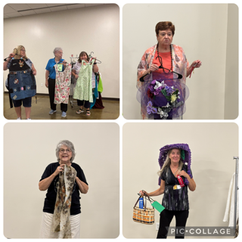

Sevier County FCE at the Sevier County Fair

The award-winning Sevier County Fair celebrated 90 continuous years in 2025 and Sevier County FCE has been with them as a supporter each of those years. We have maintained static displays, manned tables with children’s activities, promoted beef producers, egg production, UT Extension research and publications, etc. In 2025, we distributed literature and giveaways for Keep Sevier Beautiful. There were 30,000 visitors to the fair this year and FCE collected names and contact information from 12 potential new members. There is a “Meet & Greet” scheduled when it is hoped another club can be reactivated in the county. Congratulations to the Fair and Sevier County for their willingness to maintain this event each year.
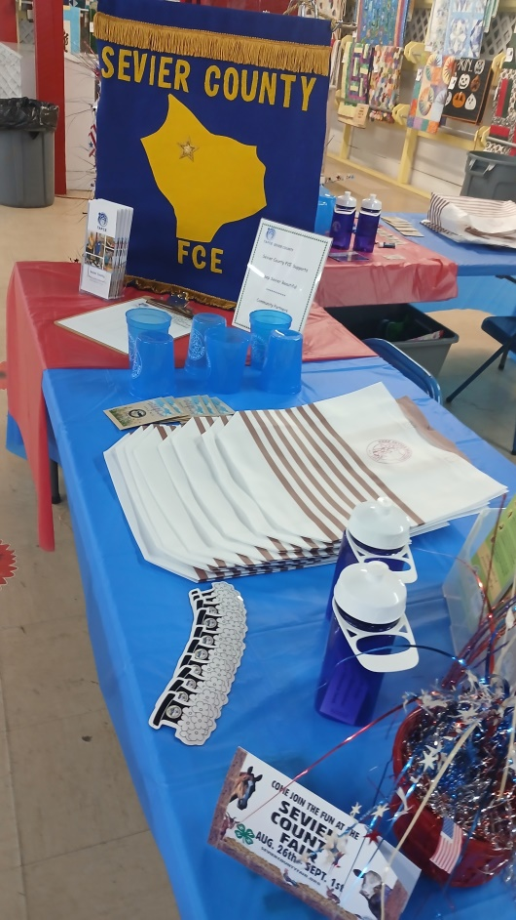

Basket Auction at Annual Member Meeting

The major fundraiser for the Eastern Region is the Themed Basket Auction at the Annual Member Meeting at TAFCE State Conference. Make your plans now to submit a basket for auction to help the region keep dues low.

- Choose a theme and container (doesn’t have to be a basket). Make a great label to identify your “basket”.
- Attach a list of the contents of your entry, including the estimated Total Retail Value.
- Wrap it up, tie a bow, and bring to the Member Meeting on Wednesday Morning, November 12, 8:00AM, Murfreesboro Embassy Suites.

TAFCE Mission Statement
To strengthen the home and community by improving the quality of life of individuals and families through continuing education, leadership development, and community service.

